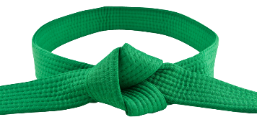
WADO KARATE UNION JUNIOR GRADING SYLLABUS 5th KYU (BLUE BELT)
Your Name ____________________ Age ____________
To pass this level the candidate must attain 60 Points out of 100 points available
Kihon Waza (Basic techniques)
Kette Junzuk: __________
Kette Gyakuzuki ______________
Junzuki no Tsukomi (Front lunge punch to the Head) ___________
Gyakuzuki no Tsukomi (Reverse Punch to Gedan) _______________
Shuto Uke (Knife hand block in cat stance)
keri Waza (Kick techniques)
From Yoi stance (Ready position)
- Front kick & Roundhouse kick from the same leg (Kekeashi) points awarded ______________
- Back kick (Uhirogeri) points awarded ______________
In fighting stance
- Moving forwards, Side kick to the body (Sokuto chudan) points awarded ______________
Renraku Waza (Combination techniques).
- Front kick, Reverse punch (Maigeri, Gyakuzuki). Points awarded ______________
- One step front kick, Side kick, Reverse punch to the body. Points awarded ______________
- Stepping forwards snap punch to the head reverse punch to the body. points awarded _____

Pair Work
Punch Blocks (Ippone Gumite 1& 2) points awarded ____________
Kata
Pinan Nidan & Shodan points awarded ___________________
Assessment date _________________________
Signature of examiner _____________________Name of Examiner __________________________
www.mabet.co.uk WhatsApp 07956 913437

