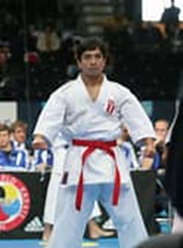
WADO KARATE UNION
JUNIOR GRADING SYLLABUS
9th KYU (RED BELT)
Your Name ____________________ Age ____________
To pass this level the candidate must attain 60 Points out of 100 points available
Basic techniques
Performed on the spot in Shiko Dachi stance (Feet turned out)
- Mid level Punch (Chudan) Points awarded ______________
- Head Punch (Jodan)Points awarded ______________
- Head Block Uke (Jodan Uke) Points awarded ______________
- Lower Block (Gedan Barai) Points awarded ______________
Kick techniques)
Performed on the spot in Yoi (or Ready) stance.
- Front Kick to the body (Maigeri)
- Roundhouse kick to the body (Mawashigeri)
Punch techniques
Performed from the spot in ready stance, hands raised.
(Step forward punch then return to ready stance)
- Front snap punch (Tobikomizuki Jodan)
- Reverse punch to the body (Gyakuzuki) Points awarded ______________
- Front punch (Junzuki) On the spot – change arms slowly, then punch fast.

Total points awarded ____________ Assessment date _________________________
Signature of examiner _____________________Name of Examiner __________________________
www.mabet.co.uk WhatsApp 07956 913437

